ĐƯỜNG LINK GIÁO ÁN ĐIỆN TỬ CÁC TỔ
TỔ | LINK | QR
Toán -Tin | https://drive.google.com/drive/folders/118MaZXv_iTqStQAbWGKO8zDULY1Bc2vI?usp=sharing | 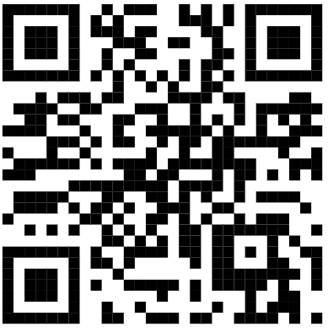
 | https://drive.google.com/file/d/1uPbwu5iy6hANwnv2_kHvgw-LAUpJlIOR/view?usp=sharing | 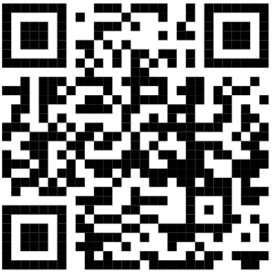
 | https://drive.google.com/drive/folders/1qGQC4ROsEbMxq9kIfk81uCYpx_Hiph1S?usp=sharing | 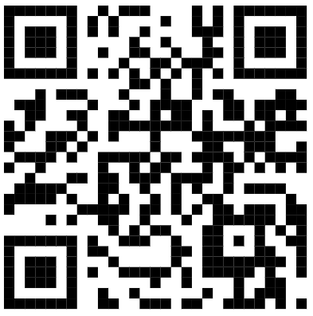
 | https://drive.google.com/drive/folders/1B62h0a0Uhr0x64jdCMxp0deDIqQ_RVsB?usp=sharing | 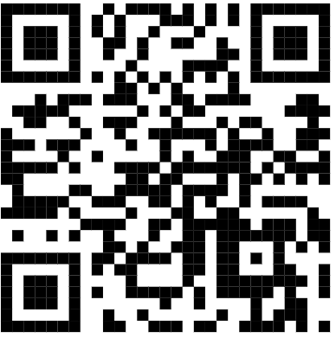
 | https://drive.google.com/file/d/1PqP5_bwUlDCCSNFzwHa8BBx1_Id9ykP1/view?usp=drive_link | 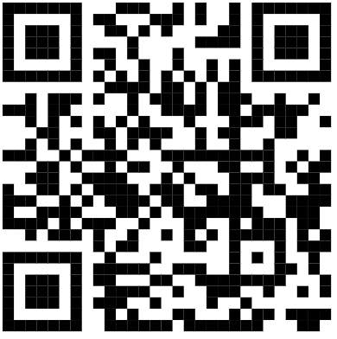
 | https://drive.google.com/drive/folders/0BwzBnxoZdTS_WHJDQ0x0dmlZT0E?resourcekey=0-XMB6tdYpZQBje2mpf7zVfg&usp=drive_link | 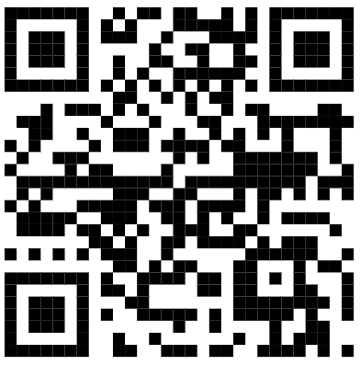
 | https://drive.google.com/drive/folders/1T320vva1HuvDyCj2nMEGIOz3fzHwrupz?usp=sharing | 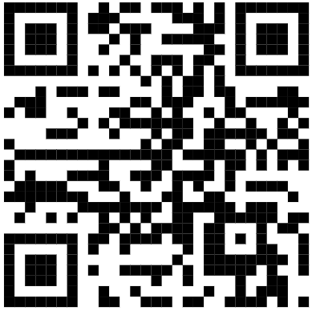
Văn – NT | https://drive.google.com/drive/folders/1pFsGAEMahWj3SkCtE6pRtL-VbwBDjZN4?usp=drive_link | 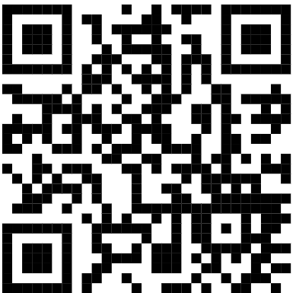
Sử - Địa | https://drive.google.com/drive/folders/19vB44onNV2Nh7EgxBle_TC55v62DSRYR?usp=drive_link | 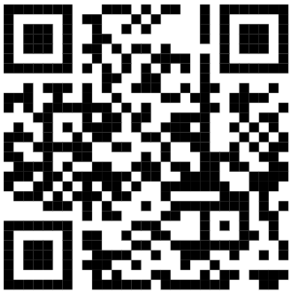
Anh - CN | https://drive.google.com/drive/folders/1CAI3qOX1jFkqfbGyjIZa8rmqDnLtSLqk?usp=sharing | 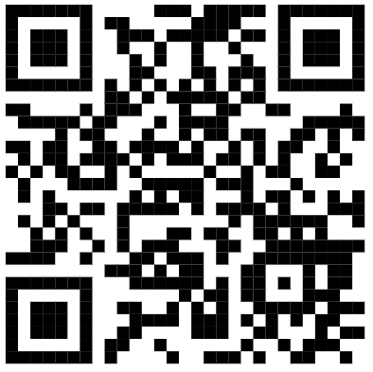
KHTN – TC | https://drive.google.com/drive/folders/1TbXR7WBrA4nFBPXEbAvibTReV6ig1u43?usp=drive_link | 